Balls. Des Balles! Bolas?

Week One – Origins
For week one, I was assigned to choose from one of several potential assignments for CIS 450-30. My choice was to design a website for a new sporting website company. I name my company ‘Balls. Des Balles! Bolas? The name came from a play on words using the word balls in three difference languages where the largest sport in the worlds use balls: soccer, basketball, football, and baseball. The theme of my executive summary is a new company with national origins with aspirations to go international by saving the world from the mental misery of COVID-19 by using sports as its vaccination. The thesis of my executive summary is to provide every type of equipment with an emphasis on safety during these dire times.
My primary resources were www.science.org for specific numbers and the origination of the COVID-19 epidemic, www.historyhit.com for historical accuracy on gladiatorial sporting events, and www.cnbc.com for detailed financial numbers on sporting in the world.
During week two, my goal is to start my journal, which I found the template in Microsoft Word, and beautify it enough to appear attractive and still detailed within the course requirements. I also plan to research how to do a detailed feasibility analysis for my company project, ‘Balls. Des Balles! Bolas?’


Balls. Des Balles! Bolas?

Week Two – Feasible or Not?
For week two, my goal is to create a feasibility analysis for my newly created corporation and its lofty goals of international gaming distribution with an emphasis on safety. A feasibility analysis/study/report is an assessment of the practicality of any proposed project or plan. In essence, I will ask myself, if the plan I proposed feasible? Does my company have the resources to complete the project? If I do not have the resources, how do I plan to obtain the resources? And if I can get the resources, what will my return on investment possibly be?
There are several items to be done during a feasibility study. I will need to accurately describe my product(s) and services. Since this is about a website, I will need to discuss the technology used. I will also need a marketing strategy to figure my return on investment.


Balls. Des Balles! Bolas?

Week Three - Risk
For week three, risk management was the topic at hand. Initially, in our weekly discussion, we were tasked with assessing risk of a new start-up that would compete head-to-head with Uber and Lyft. The caveat would be to only use self-driving automobiles as the main attractant. I surmised that to instead of trying to still all of their business, which is primarily 20 to 35 year-olds, but to focus on the older generation of 35 – 60. To attract that demographic, I deduced to use only BMW self-driving vehicles, which is considered a primary brand for older adults, and also a leader in the autonomous vehicle industry. I identified the main risks and how to manage them.
My next item on the week three calendar would be completion of my week three assignment as it relates to risk management as it relates to my current project. As it is known, my current project is to create a website for my own start-up, “Balls. Des Balles! Bolas?” The goal of my project is to become a major distributor of sporting equipment internationally with an emphasis on safety goods.
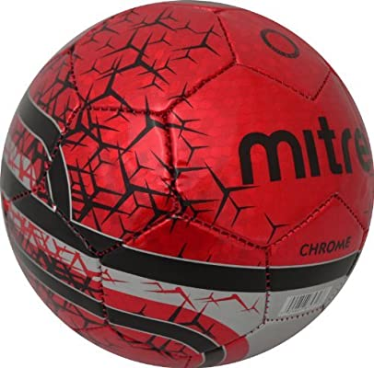

Balls. Des Balles! Bolas?

Week 4 – Resources and Setup

For week four, my project has been focused on the resources need to procure building a quality website for the startup business ‘Balls. Des Balles! Bolas’. The hardest part of the website is the initial phase of making it adaptable to multiple counties and bilingual for up to twenty languages. Understandably, every language needs not be added due to the lack of profitability in every area of the world. The languages I think are more important are as follows, based on the largest cities or countries where professional sports occur::
- (Spanish) Barcelona
- (English) London
- (Japanese) Tokyo
- (Mandarin) Beijing
- (German) Berlin
- (Portuguese) Rio de Janeiro
- (Arabic) Algeria
- (Hindi) Kanpur
- (Russian) Russia
- Korean (Korea)
- Zulu and Venda (South Africa)
The goal will be to give the customer an initial option to choose the language of their preference with a spoken word in every language and sprawling across the screen like a car sales banner. It would be something like you see on the Wikipedia initial page where you have a spinning globe and the user selects their country on the globe first, then a shape of their county comes up and confirms the language of their choice. Then I would set up the CSS option of drop boxes and form for the user to set up an account to access the site.

Balls. Des Balles! Bolas?

Week Five – Security Measures
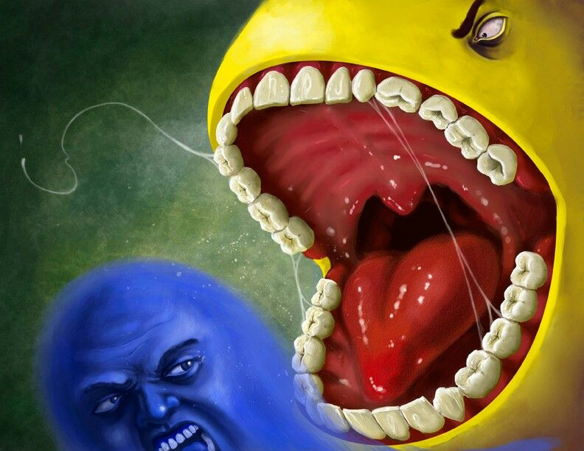
Week five has been all about protecting the investment and the customers from cyber-crimes. In my studies and research, I have found that the worst potential for a crime against our newfound company is malware and ransomware attacks. Discouraging enough, of every article I read, none give a definitive way to avoid ransomware, just tips and ways to ‘run and hide while you can.” I think this is because malware is the most lucrative of all types of cyber crime, and even after a patch is created to stop it, you really only stop that form of malware. Malware constantly adjusts and reforms to new ways to attack a system and avoid the previous parameters that snatched it up previously. I compare malware to the old fictitious moniker of the criminal syndicate H.Y.D.R.A. in Marvel Comics, “Cut one head off, two more will take its place.”
The best thing to do is make sure you have a quality antivirus and that you keep it up to date. The problem is, of course, that removing the ransomware itself doesn't get your files back. The only reliable guarantee of recovery is maintaining a hardened cloud backup of your important files.

